Project Design Phase – II
Technology Stack (Architecture & Stack)

Date | 14/7/2026
Team ID | SWTID-2026-9161
Project Name | EduGenie – Google Gemini Powered Learning Assistant
Maximum Marks

Technical Architecture
The EduGenie Learning Assistant follows a modular three-layer architecture consisting of the Presentation Layer, Application Layer, and AI & Data Layer. This architecture ensures scalability, maintainability, and efficient communication between the frontend, backend, AI models, and database.
Architecture Flow
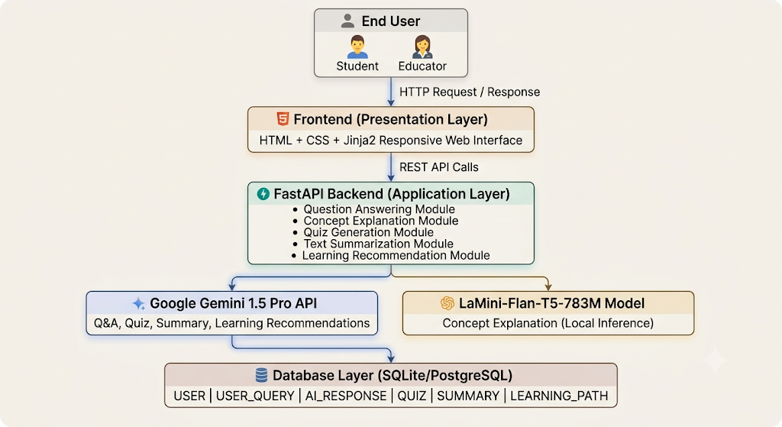

Table 1: Components & Technologies
S.No | Component | Description | Technology
1 | User Interface | Web interface for students and educators to interact with EduGenie | HTML5, CSS3, Jinja2
2 | Application Logic – 1 | Handles Question Answering functionality | Python, FastAPI
3 | Application Logic – 2 | Handles Concept Explanation using lightweight local AI model | Python, LaMini-Flan-T5-783M
4 | Application Logic – 3 | Handles Quiz Generation, Summarization, and Learning Recommendations | Google Gemini 1.5 Pro API
5 | Database | Stores users, queries, AI responses, quizzes, summaries, and learning paths | SQLite / PostgreSQL
6 | Cloud AI Service | Cloud-based Generative AI processing | Google Gemini API
7 | File Storage | Stores project files, templates, static resources, and configuration | Local File System
8 | External API – 1 | AI-powered educational content generation | Google Gemini API
9 | External API – 2 | Environment variable management and configuration | Python Dotenv
10 | Machine Learning Model | Generates educational explanations using a lightweight transformer model | LaMini-Flan-T5-783M
11 | Infrastructure (Server / Cloud) | Local application deployment and API hosting | Uvicorn ASGI Server, Local System

Table 2: Application Characteristics
S.No | Characteristic | Description | Technology
1 | Open-Source Frameworks | Frameworks used to build the application | FastAPI, Python, Jinja2, SQLAlchemy, HTML5, CSS3
2 | Security Implementations | Protects API keys and user credentials using environment variables and secure coding practices | Python Dotenv, Password Hashing, HTTPS (deployment), Input Validation
3 | Scalable Architecture | Modular architecture with separate AI modules and REST APIs allowing future expansion | FastAPI Modular Architecture, REST APIs
4 | Availability | Application is accessible whenever the FastAPI server is running locally or deployed on a cloud platform | Uvicorn, FastAPI
5 | Performance | Fast request processing with asynchronous APIs and lightweight local AI model for explanations | FastAPI (Async), Uvicorn, Google Gemini API, LaMini-Flan-T5

Technology Stack Summary
Category | Technology Used
Programming Language | Python 3.10+
Backend Framework | FastAPI
Frontend | HTML5, CSS3, Jinja2
AI Model (Cloud) | Google Gemini 1.5 Pro
AI Model (Local) | LaMini-Flan-T5-783M
Database | SQLite / PostgreSQL
ORM | SQLAlchemy
API Server | Uvicorn
Environment Management | Python Dotenv
Version Control | Git & GitHub
IDE | Visual Studio Code / PyCharm
Operating System | Windows, Linux, macOS

Advantages of the Selected Technology Stack
- FastAPI provides high-performance REST APIs with automatic documentation.
- Google Gemini 1.5 Pro delivers accurate and context-aware responses for educational tasks.
- LaMini-Flan-T5 enables lightweight, offline-friendly concept explanations.
- HTML, CSS, and Jinja2 create a responsive and user-friendly interface.
- SQLAlchemy simplifies database operations and supports multiple relational databases.
- SQLite allows easy local development, while PostgreSQL supports scalable deployment.
- Uvicorn offers fast ASGI-based application hosting with auto-reload during development.
- The modular architecture makes the system easy to maintain, test, and extend with new AI-powered educational features.

Conclusion
The EduGenie Learning Assistant uses a modern and scalable technology stack that integrates FastAPI, Google Gemini 1.5 Pro, LaMini-Flan-T5-783M, SQLite/PostgreSQL, SQLAlchemy, HTML, CSS, and Jinja2. This architecture ensures efficient frontend-backend communication, intelligent AI-powered educational assistance, secure data management, and flexibility for future enhancements such as multilingual support, mobile applications, learning analytics, and cloud deployment.

